LIBRIS

Library Management System
Full Technical Documentation

Version 1.0.0

Author Bhungani Kenil Shaileshbhai
Team Venil Virani
Nishi Macwan
Maheshkumar Virani Dhruv

Date April 2026

Platform Python 3.10 · Flask · Jinja2

Stack HTML5 · CSS3 · JavaScript · JSON

Tool Trunk.io (code quality)

Table of Contents

- Introduction 3
  - Project Overview 3
  - Purpose of This Document 3
  - Scope & Audience 3
- System Architecture 4
  - High-Level Architecture 4
  - Technology Stack 4
  - Data Flow 5
- Project Structure 6
  - Root Directory 6
  - /data Directory 6
  - /static Directory 7
  - /templates Directory 7
  - /.trunk Directory 8
  - / pycache Directory 8
- Installation & Setup 9
  - Prerequisites 9
  - Installation Steps 9
  - Running the Application 9
  - First Launch 10
- Module Reference 11
  - app.py — Flask Application 11
  - book.py — Book Class 12
  - user.py — User Class 13
  - library.py — Helper Functions 14
- API Route Reference 15
  - Dashboard Routes 15
  - Book Routes 15
  - User Routes 16
  - Borrow & Return Routes 16
  - Search & Activity Routes 17
  - Statistics Routes 17
- User Interface & Pages 18
  - Dashboard 18
  - Books Management Page 19
  - Add Book Page 19
  - Book Detail Page 20
  - Members Management Page 20
  - Add Member Page 21
  - Borrow & Return Page 21
  - Search Page 22
  - Activity Log Page 22
  - Statistics Page 23
- Data Storage Reference 24
  - books.json Schema 24
  - users.json Schema 25
  - activity.json Schema 25
- Frontend Reference 26
  - style.css 26
  - script.js 26
  - Jinja2 Template Hierarchy 27
- Code Quality — Trunk 28
- Usage Guide 29
  - Adding a Book 29
  - Registering a Member 29
  - Borrowing a Book 30
  - Returning a Book 30
  - Searching the Catalogue 30
- Potential Improvements 31
- Glossary 32

Chapter 1
Introduction
Project overview, purpose, and intended audience

Project Overview
Libris is a full-featured, web-based Library Management System developed using Python 3.10 and the Flask micro-framework. It provides a comprehensive platform for managing a library's catalogue of books and its registered members, tracking borrowing and returning of books, searching the catalogue, and generating activity logs and statistical reports — all accessible through a clean, responsive browser-based interface.
The system requires no external database server. All data is persisted in JSON flat files in a local data/ directory, making the system easy to deploy, back up, and migrate. Libris is well-suited for small to medium-sized libraries, school libraries, office book collections, or personal book tracking.

Purpose of This Document
This document serves as the complete technical and user reference for the Libris Library Management System. It covers the system architecture, module descriptions, API route reference, data storage schemas, frontend structure, installation guide, and detailed usage instructions.

Scope & Audience
This document is intended for the following audiences:
    - Developers — who need to understand the codebase, add features, or fix issues.
    - System Administrators — who need to deploy, configure, and maintain the application.
    - Library Staff / End Users — who need guidance on using the web interface.
    - Technical Reviewers — conducting code review or project assessment.
Note: This document covers Libris version 1.0.0. Features or behaviours may differ in future releases.

Chapter 2
System Architecture
High-level design, technology stack, and data flow

High-Level Architecture
Libris follows a classic Model-View-Controller (MVC) architectural pattern adapted for Flask:
    - Model Layer: book.py, user.py, library.py — define data structures and business logic.
    - View Layer: templates/ directory — Jinja2 HTML templates that render the user interface.
    - Controller Layer: app.py — Flask routes that receive HTTP requests, invoke the model, and return rendered views.
    - Persistence Layer: data/ directory — JSON files for storage (no database server required).

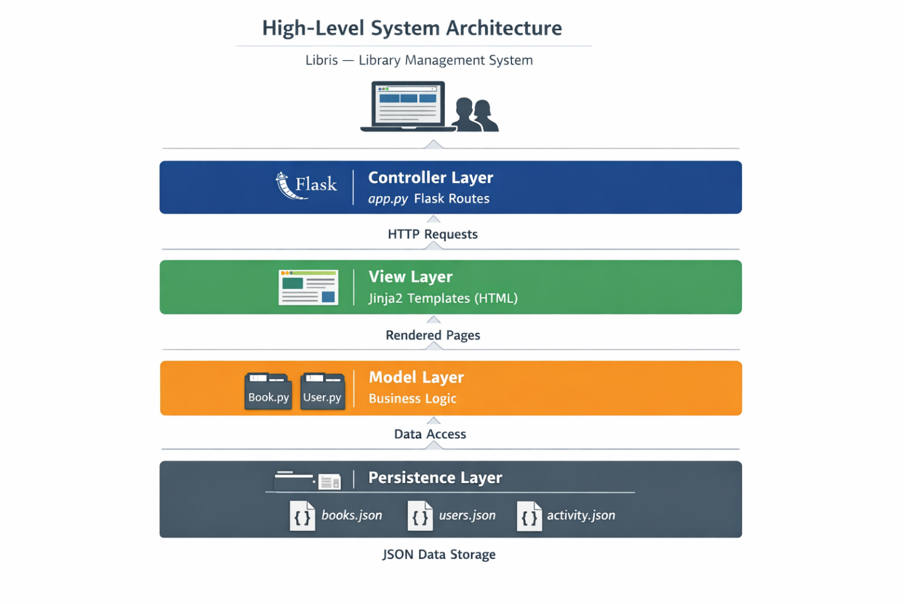

Figure 2.1 — High-Level System Architecture

Technology Stack

Layer | Technology | Purpose
Backend Language | Python 3.10 | Core application logic
Web Framework | Flask | HTTP routing and request/response handling
Templating | Jinja2 | Dynamic HTML rendering (built into Flask)
Frontend | HTML5 / CSS3 | Page structure and global styling
Interactivity | JavaScript | Client-side validation and UI behaviour
Data Storage | JSON Files | Flat-file persistence — no DB server needed

Layer | Technology | Purpose
Code Quality | Trunk.io | Automated linting and formatting

Data Flow
The complete request-response cycle within Libris:
    - Step 1 — Browser Request: The user navigates to a URL, generating an HTTP GET or POST request.
    - Step 2 — Route Matching: Flask's URL dispatcher in app.py matches the URL to a view function.
    - Step 3 — Data Loading: The view function reads the relevant JSON file into a Python list.
    - Step 4 — Business Logic: The view function processes the data and applies changes.
    - Step 5 — Data Saving: If data was modified, the updated list is written back to the JSON file.
    - Step 6 — Template Rendering: Flask passes data to a Jinja2 HTML template.
    - Step 7 — HTTP Response: The rendered HTML is returned and displayed in the browser.

Chapter 3
Project Structure
Complete file and folder reference

Root Directory
The root of the project (C:\Users\bhung\library-management\) contains:

File / Folder | Type | Size | Description
app.py | Python Script | ~15 KB | Main Flask application — all routes and logic
book.py | Python Script | ~2 KB | Book class definition
library.py | Python Script | ~3 KB | Helper and utility functions
user.py | Python Script | ~2 KB | User (Member) class definition
data/ | Folder | ~5 KB | JSON persistent data storage
static/ | Folder | ~29 KB | CSS and JavaScript assets
templates/ | Folder | ~40 KB | Jinja2 HTML templates
.trunk/ | Folder | — | Trunk.io code quality tooling
pycache / | Folder | ~17 KB | Python compiled bytecode cache

/data Directory
Stores all application data as plain JSON files, created automatically on first run.

File |  | Size | Contents
activity.json |  | 2 KB | Array of activity log entries (borrow, return, add events)
books.json |  | 2 KB | Array of book record objects
users.json |  | 1 KB | Array of library member record objects
 | Note: activity.json is automatically capped at 100 entries. Older entries are removed as new ones are added.

/static Directory

File | Type | Size | Description
style.css | CSS Stylesheet | 26 KB | Complete global styling — layout, navigation, cards, tables, forms, responsive design
script.js | JavaScript | 3 KB | Client-side interactivity — form validation, dynamic dropdowns, flash message dismissal

/templates Directory
Contains 11 Jinja2 HTML templates. All extend base.html.

Template File | Size | Route(s) | Description
base.html | 6 KB | All pages | Base layout — nav, header, footer, flash messages
index.html | 5 KB | / | Dashboard — stats, recent books, recent activity
books.html | 4 KB | /books | Full catalogue list with status indicators
add_book.html | 3 KB | /books/add | Form to add a new book
book_detail.html | 4 KB | /books/ | Individual book info and borrow history
users.html | 3 KB | /users | Member list with borrowed book counts
add_user.html | 4 KB | /users/add | Form to register a new member
borrow.html | 5 KB | /borrow | Borrow / return form
search.html | 10 KB | /search | Search interface and results
activity.html | 2 KB | /activity | Full chronological activity log
stats.html | 4 KB | /stats | Genre breakdown and top borrowers

/.trunk Directory

Item | Type | Purpose
trunk.yaml | YAML Config | Main Trunk configuration — enabled linters, formatters, tools
.gitignore | Git Ignore | Trunk-specific gitignore rules
configs/ | Folder | Per-tool configuration files
plugins/ | Folder | Trunk plugin definitions
actions/ | Folder | Custom Trunk CI actions
tools/ | Folder | Trunk-managed tool binaries

Item | Type | Purpose
logs/ | Folder | Execution logs from Trunk runs
out/ | Folder | Output artifacts from Trunk runs
notifications/ | Folder | Notification channel settings

/ pycache Directory
Auto-generated by Python. Stores compiled .pyc bytecode. Add to .gitignore and never edit manually.

File | Size | Source
book.cpython-310.pyc | 2 KB | Compiled from book.py
email_utils.cpython-310.pyc | 10 KB | Compiled from email_utils.py
library.cpython-310.pyc | 3 KB | Compiled from library.py
user.cpython-310.pyc | 2 KB | Compiled from user.py

Chapter 4
Installation & Setup
Prerequisites, installation steps, and first launch

Prerequisites

Requirement | Version | Notes
Python | 3.10+ | Verified — cpython-310 bytecode in pycache
pip | Latest | Bundled with Python 3.10+
Flask | 2.x+ | The only required external package
Browser | Any modern | Chrome, Firefox, Edge, or Safari
OS | Any | Windows, macOS, or Linux

Installation Steps

Step 1 — Clone the Repository
Open a terminal or Command Prompt and run:
git clone https://github.com/your-username/library-management.git cd
library-management

Step 2 — Install Flask
Install the only required dependency:
pip install flask

Step 3 — Verify Installation
Confirm Flask installed correctly:
python -m flask --version

Running the Application
Start the Flask development server from the project root:
python app.py
Open any browser and navigate to http://127.0.0.1:5000

First Launch
On first launch, app.py automatically creates the data/ directory and initialises the three JSON data files as empty arrays. No manual setup is required.
Note: The Flask development server is for development only. For production, use Gunicorn with a reverse proxy such as Nginx.
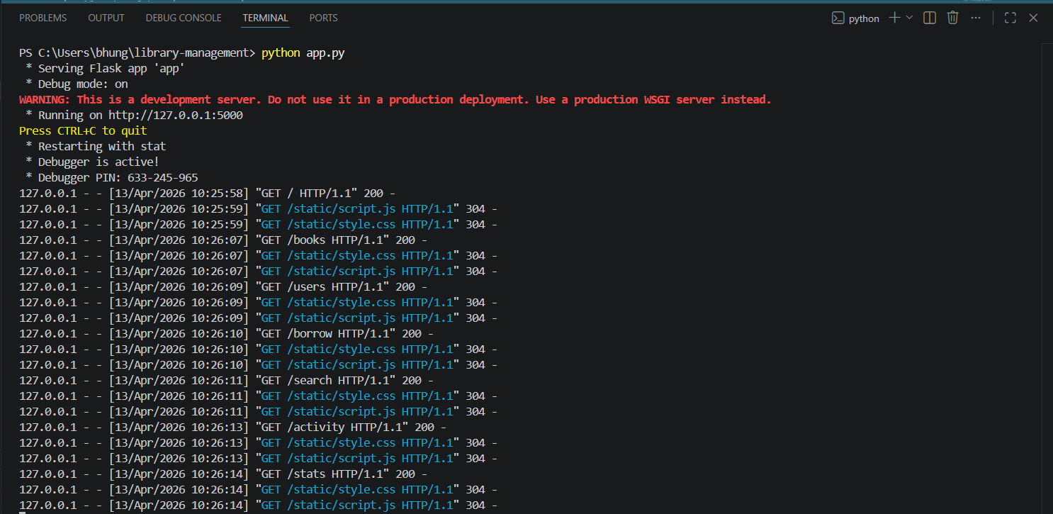
Figure 4.1 — Application startup terminal output

Chapter 5
Module Reference
Detailed reference for all Python source files

app.py — Flask Application
app.py is the main entry point and controller of Libris. It initialises the Flask application, defines all URL routes, implements data helper functions, and handles the complete HTTP request-response lifecycle.

Configuration Variables

Variable | Value | Purpose
app.secret_key | libris-secret-key-2024 | Signs session cookies and flash messages
DATA_DIR | data | Directory path for JSON storage files
BOOKS_FILE | data/books.json | Path to books data file
USERS_FILE | data/users.json | Path to users data file
ACTIVITY_FILE | data/activity.json | Path to activity log file

Data Helper Functions

Function | Returns | Description
load_books() | list | Reads and returns books.json as a Python list
save_books(books) | None | Serialises and writes the books list to books.json
load_users() | list | Reads and returns users.json as a Python list
save_users(users) | None | Serialises and writes the users list to users.json
load_activity() | list | Reads and returns activity.json as a Python list
save_activity(activity) | None | Writes activity list to file (capped at 100 entries)
log_activity(type,user,book) | None | Creates and prepends a new activity log entry

book.py — Book Class
Represents a single book record. Encapsulates all attributes and provides borrow/return methods.

Constructor

Book(title, author, year, isbn, genre='', description='')

Parameter | Type | Required | Description
title | str | Yes | Full title of the book
author | str | Yes | Author name
year | str | Yes | Publication year
isbn | str | Yes | Unique ISBN — primary key
genre | str | No | Genre / category (default: empty string)
description | str | No | Short description (default: empty string)

Methods

Method | Parameters | Returns | Description
borrow(user_name) | user_name: str | None | Sets available=False, borrowed_by=user_name
return_book() | None | None | Sets available=True, borrowed_by=None
to_dict() | None | dict | Returns all attributes as dict for JSON storage
str () | None | str | Human-readable: 'Title by Author (Year) — Status'
repr () | None | str | Dev repr: 'Book(title=..., isbn=...)'

user.py — User Class
Represents a library member. Stores contact info and maintains a list of borrowed ISBNs.

Constructor
User(name, user_id, email='', phone='')

Parameter | Type | Required | Description
name | str | Yes | Full name of the member
user_id | str | Yes | Unique member identifier (e.g., U001)
email | str | No | Email address (default: empty string)
phone | str | No | Phone number (default: empty string)

Methods

Method | Parameters | Returns | Description
borrow_book(isbn) | isbn: str | None | Appends ISBN to borrowed_books if not already present
return_book(isbn) | isbn: str | None | Removes ISBN from borrowed_books if present
to_dict() | None | dict | Returns all attributes as dict for JSON storage
str () | None | str | 'Member: Name (ID: X) — N book(s) borrowed'
repr () | None | str | Dev repr: 'User(name=..., user_id=...)'

library.py — Helper Functions
Standalone utility functions operating on in-memory lists. No file I/O performed.

Function | Parameters | Returns | Description
search_by_title(library, title) | list, str | list | Partial, case-insensitive title match
search_by_author(library, author) | list, str | list | Partial, case-insensitive author match
search_by_isbn(library, isbn) | list, str | dict|None | Exact ISBN lookup — single book or None
delete_book(library, isbn) | list, str | bool | Removes book in-place; returns True/False
get_available_books(library) | list | list | Returns all books where available == True
get_borrowed_books(library) | list | list | Returns all books where available == False
get_stats(library, users) | list, list | dict | Returns total, available, borrowed, utilization_pct

Chapter 6
API Route Reference
Complete HTTP endpoint documentation

Dashboard Routes

Route | Method | Template | Description
/ | GET | index.html | Renders dashboard: total books, available, borrowed, total members, 5 most recent books, 6 most recent activity entries.

Book Routes

Route | Method | Template | Description
/books | GET | books.html | Displays the full book catalogue with availability status.
/books/add | GET | add_book.html | Renders the Add Book form.
/books/add | POST | Redirect | Validates form, checks duplicate ISBN, saves book, logs activity, redirects to /books.
/books/ | GET | book_detail.html | Renders detail page for a single book with borrow history.
/books/delete/ | POST | Redirect | Deletes a book by ISBN and redirects with flash message.

User Routes

Route | Method | Template | Description
/users | GET | users.html | Displays all registered members.
/users/add | GET | add_user.html | Renders Register Member form with existing_ids for duplicate checking.
/users/add | POST | Redirect | Validates form, checks duplicate user_id, saves member, redirects.
/users/delete/ | POST | Redirect | Removes a member and redirects with flash message.

Borrow & Return Routes

Route | Method | Template | Description
/borrow | GET | borrow.html | Splits books into available and borrowed lists; renders borrow/return page.
/borrow | POST | Redirect | Reads action (borrow/return), isbn, user_id. Borrow: marks book unavailable, adds ISBN to user. Return: marks book available, removes ISBN. Logs activity. Redirects.

Search & Activity Routes

Route | Method | Template | Description
/search | GET | search.html | Case-insensitive partial match across title, author, ISBN, and genre.
/activity | GET | activity.html | Loads and renders the full activity log from activity.json.

Statistics Routes

Route | Method | Template | Description
/stats | GET | stats.html | Computes: total/available/borrowed counts, genre breakdown sorted by count, and top 5 borrowers from the activity log.

Chapter 7
User Interface & Pages
Detailed description of every page with screenshot placeholders

  - Dashboard (Home Page)

Route: /
The Dashboard is the first page a user sees. It provides an at-a-glance summary of the entire library.

Key Features:
    - Four summary stat cards: Total Books, Available Books, Borrowed Books, Total Members
    - A 'Recent Books' panel showing the 5 most recently added books
    - A 'Recent Activity' panel showing the 6 most recent events
    - Navigation bar linking to all major sections

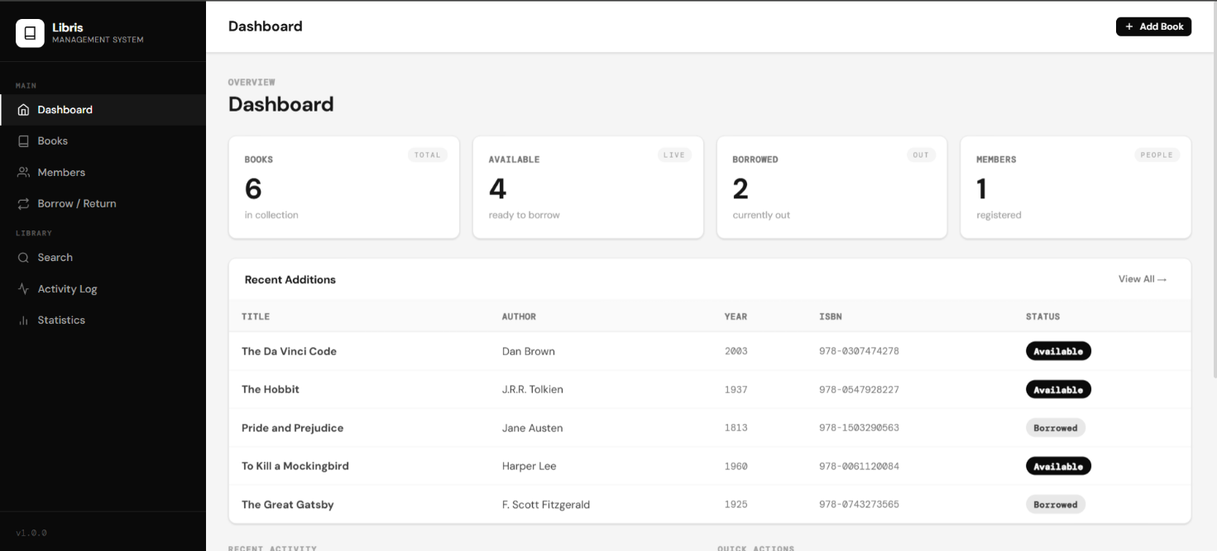
Figure 7.1 — Dashboard (Home Page)

Books Management Page
Route: /books
Lists every book in the catalogue with title, author, year, ISBN, genre, and availability status.

Key Features:
    - Complete book catalogue in a tabular layout
    - Availability status badge — Available / Borrowed
    - Link to each book's detail page
    - Delete button per book
    - 'Add Book' navigation button

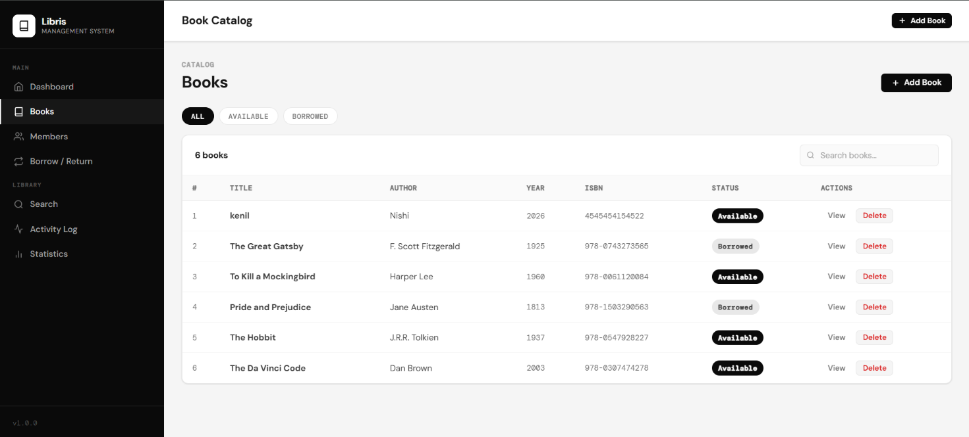

Figure 7.2 — Books Management Page

Add Book Page
Route: /books/add
Form for adding new books. Validates that the ISBN is unique before saving.

Key Features:
    - Required: Title, Author, Year, ISBN
    - Optional: Genre, Description (textarea)
    - Duplicate ISBN validation — error flash if ISBN exists
    - Success flash on addition

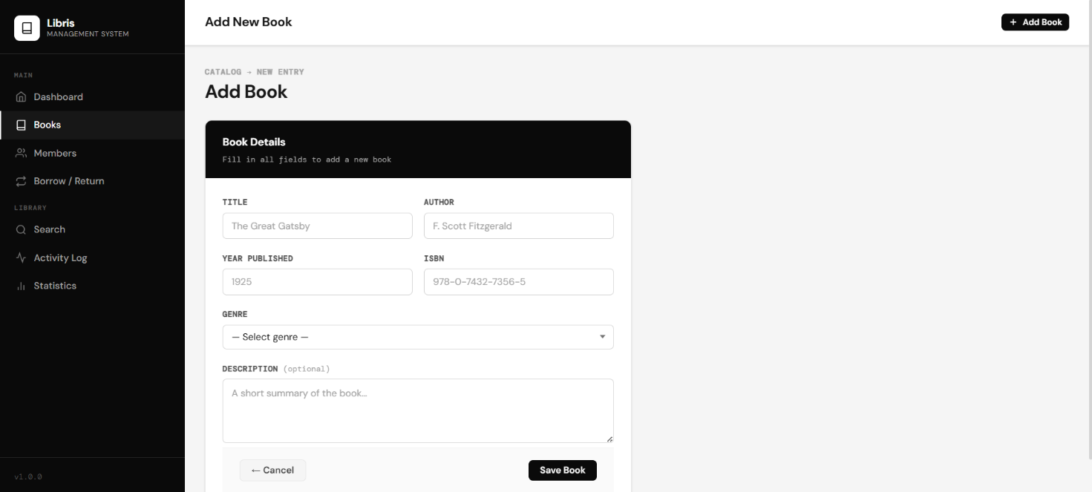
Figure 7.3 — Add Book Page

Book Detail Page
Route: /books/

Shows all information about a single book and its complete borrowing history.

Key Features:
    - All book fields displayed
    - Current availability status and borrower name
    - Chronological borrow/return history (last 10 entries)
    - Delete button for the book

Figure 7.4 — Book Detail Page

Members Management Page
Route: /users
Lists all registered members with contact details and borrow counts.

Key Features:
    - Member table: Name, ID, Email, Phone, Borrowed book count
    - Delete button per member
    - 'Add Member' navigation button

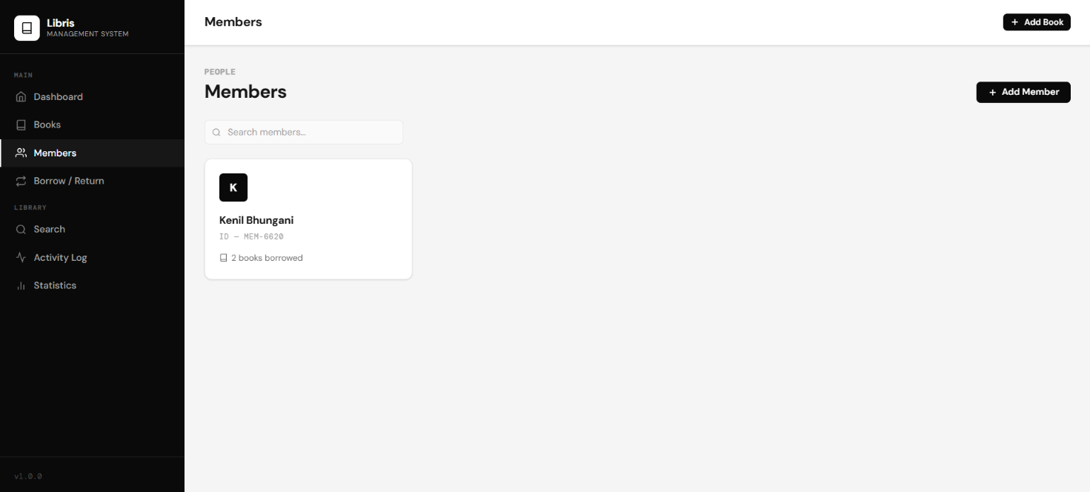

Figure 7.5 — Members Management Page

Add Member Page
Route: /users/add
Registration form for new library members.

Key Features:
    - Required: Full Name, Member ID
    - Optional: Email, Phone
    - Client-side duplicate ID checking
    - Success / error flash messages
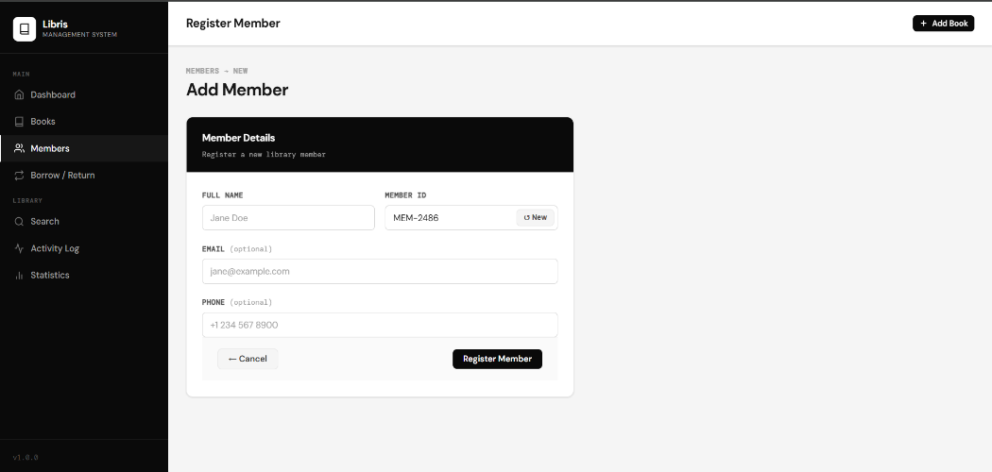
Figure 7.6 — Add Member Page

Borrow & Return Page
Route: /borrow
The operational core of Libris. Issues books and records returns.

Key Features:
    - Available Books panel — all books open for borrowing
    - Borrowed Books panel — all on-loan books with borrower names
    - Issue Book form: select book, enter Member ID, click Issue
    - Return Book form: select book, enter Member ID, click Return
    - Flash messages confirming each action
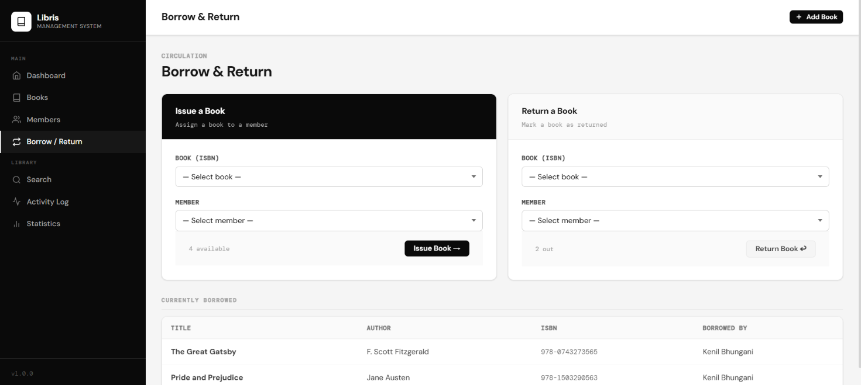
Figure 7.7 — Borrow & Return Page

Search Page
Route: /search
Search across the entire catalogue by any keyword.

Key Features:
    - Search input field with submit button
    - Results with full book details
    - Partial and case-insensitive matching
    - Result count displayed
    - Links to individual book detail pages

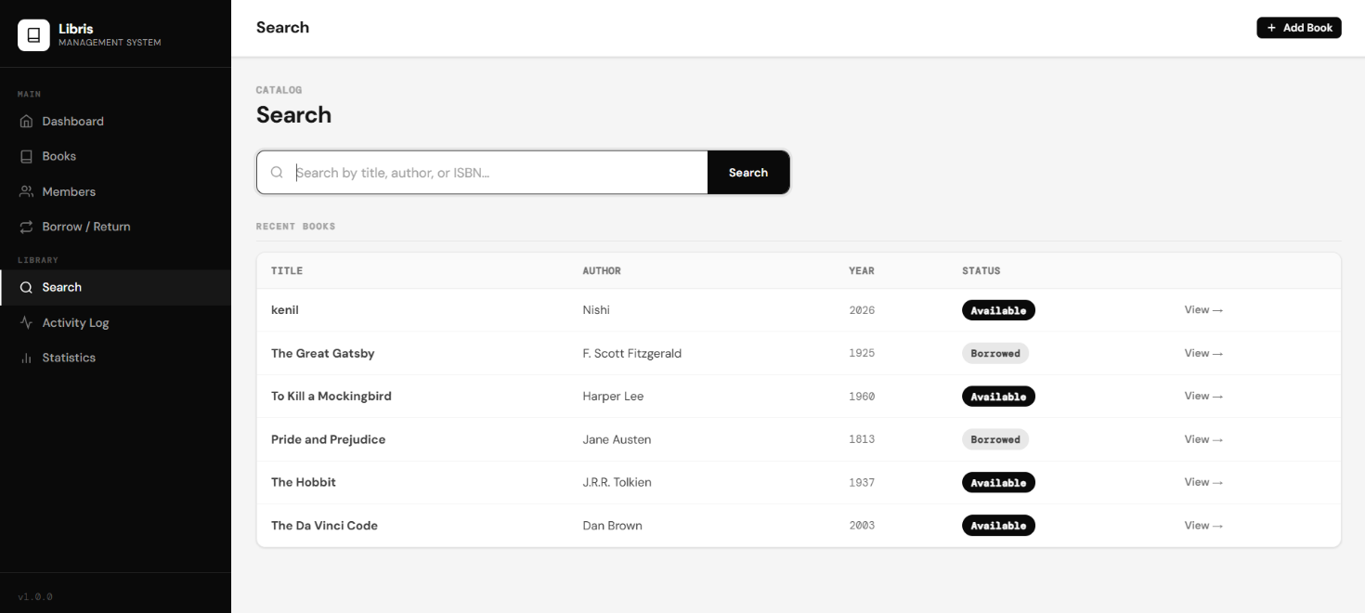
Figure 7.8 — Search Page

Activity Log Page
Route: /activity
Chronological record of all borrow, return, and addition events.

Key Features:
    - Entries listed newest first
    - Each entry: event type, member name, book title, date
    - Log capped at 100 entries

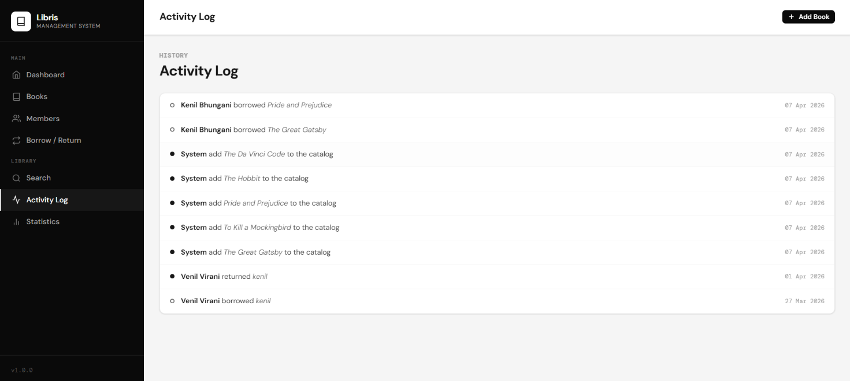
Figure 7.9 — Activity Log Page

Statistics Page
Route: /stats
Analytical insights into library usage patterns.

Key Features:
    - Summary stats: Total, Available, Borrowed, Members
    - Genre Breakdown: books per genre, sorted by most popular
    - Top 5 Borrowers leaderboard from the activity log

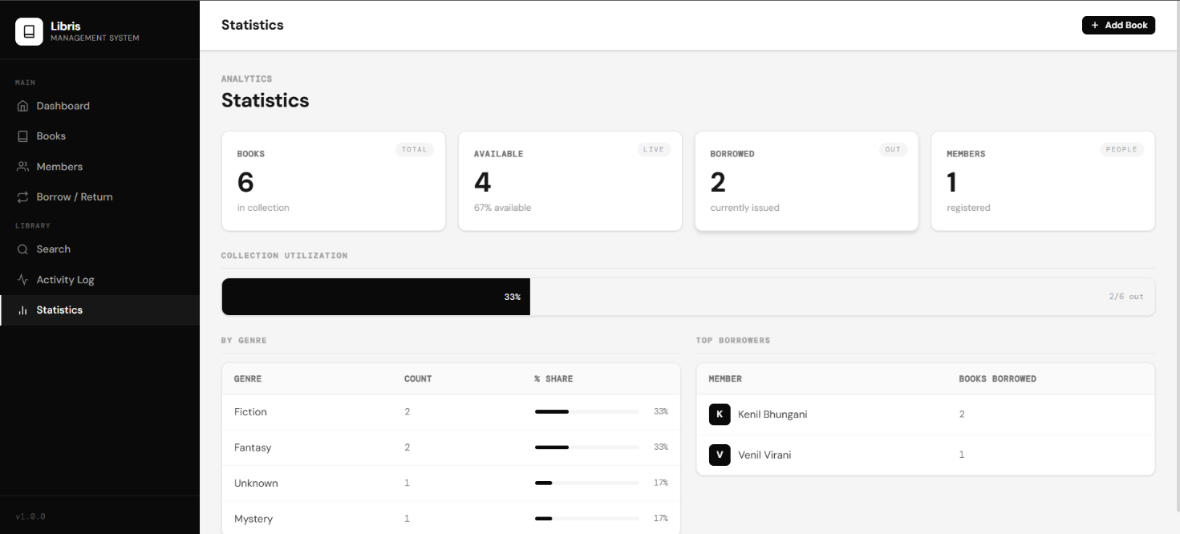
Figure 7.10 — Statistics Page

Chapter 8
Data Storage Reference
JSON schema documentation for all data files

books.json Schema

Field | Type | Required | Description
title | string | Yes | Full book title
author | string | Yes | Author's full name
year | string | Yes | Publication year (stored as string)
isbn | string | Yes | Unique ISBN identifier — primary key
genre | string | No | Genre or category label (may be empty)
description | string | No | Short description (may be empty)
available | boolean | Yes | true = available; false = currently borrowed
borrowed_by | string | null | Yes | Current borrower name, or null if available
[ { "title": "The Great Gatsby", "author": "F. Scott Fitzgerald", "year": "1925", "isbn": "9780743273565", "genre": "Fiction", "description": "A story of wealth and ambition.", "available": false, "borrowed_by": "Alice
Johnson" } ]

users.json Schema

Field | Type | Required | Description
name | string | Yes | Full name of the member
user_id | string | Yes | Unique member ID — primary key
email | string | No | Email address (may be empty)
phone | string | No | Phone number (may be empty)
borrowed_books | array[string] | Yes | ISBNs of books currently borrowed
[ { "name": "Alice Johnson", "user_id": "U001", "email": "alice@example.com", "phone": "9876543210", "borrowed_books":
["9780743273565"] } ]

activity.json Schema

Field | Type | Values | Description
type | string | 'borrow', 'return', 'add' | The type of library event
user | string | Member name or 'System' | Member involved, or 'System' for additions
book | string | Book title | Full title of the book involved
date | string | DD Mon YYYY | Event date, e.g. '10 Apr 2026'
[ { "type": "borrow", "user": "Alice Johnson", "book": "The Great Gatsby",
"date": "10 Apr 2026" }, { "type": "add", "user": "System", "book": "The Great Gatsby", "date": "07 Apr 2026" } ]

Chapter 9
Frontend Reference
Stylesheet, JavaScript, and template hierarchy

  - style.css (26 KB)
The single global stylesheet linked in base.html, covering:
    - Layout & Grid: Page wrappers, container widths, flexbox and grid layouts.
    - Navigation Bar: Horizontal top nav with active link indicators.
    - Stat Cards: Dashboard summary cards with hover effects.
    - Tables: Alternating row colours, header styling, borders.
    - Forms: Input fields, textareas, dropdowns, labels, and buttons.
    - Flash Messages: Dismissible alert banners for success and error states.
    - Availability Badges: Status pills — Available / Borrowed.
    - Responsive Design: Media queries for tablet and mobile.

  - script.js (3 KB)
Adds client-side interactivity:
    - Flash Message Dismissal: Allows users to manually close notification banners.
    - Form Validation: Client-side checks before form submission.
    - Dynamic Dropdowns: Filters dropdown options based on user selection.
    - Auto-dismiss Alerts: Flash messages auto-dismiss after a timeout.

Jinja2 Template Hierarchy
All 11 templates extend base.html and override these blocks:

Block Name | Purpose
title | Sets the browser tab title for each page
content | Main page content — each child template fills this block
scripts | Optional extra JavaScript for page-specific needs
Example child template:
{% extends "base.html" %} {% block title %}Books — Libris{% endblock %} {%
block content %} Book Catalogue ... page content ... {% endblock %}

Chapter 10
Code Quality — Trunk
Linting, formatting, and automated code checks

  - Overview
Libris uses Trunk (https://trunk.io) as its code quality platform. Trunk manages linters, formatters, and static analysis tools in a single unified configuration stored in the .trunk/ directory.

  - trunk.yaml
The main Trunk configuration file. Specifies enabled linters, formatters, versions, and custom settings. Last modified 08-04-2026.

  - Running Trunk

Command | Description
trunk check | Run all enabled linters and report issues
trunk fmt | Auto-format all source files
trunk check --all | Check all project files (not just changed files)
trunk upgrade | Upgrade Trunk and all managed tool versions

  - .trunk/.gitignore
Trunk's own .gitignore prevents tool binaries and generated output from being committed. Typically ignores the tools/, out/, and logs/ directories.

Chapter 11
Usage Guide
Step-by-step instructions for all core workflows

Adding a Book
    - Step 1: Click Books in the navigation bar.
    - Step 2: Click the Add Book button.
    - Step 3: Fill in Title, Author, Year, and ISBN (required).
    - Step 4: Optionally fill in Genre and Description.
    - Step 5: Click Add Book. A success message confirms the addition.
Note: The ISBN must be unique. A duplicate ISBN will show a red error message.

Registering a Member
    - Step 1: Click Members in the navigation bar.
    - Step 2: Click the Add Member button.
    - Step 3: Enter Full Name and a unique Member ID (e.g., U001).
    - Step 4: Optionally enter Email and Phone.
    - Step 5: Click Register. A success message confirms registration.
Note: The Member ID must be unique across all registered members.

Borrowing a Book
    - Step 1: Click Borrow / Return in the navigation bar.
    - Step 2: In the Issue Book form, select the book from the available list.
    - Step 3: Enter the Member ID of the borrower.
    - Step 4: Click Issue Book. The book status changes to 'Borrowed'.
Note: Only available books appear in the issue form. One book can only be borrowed by one member at a time.

Returning a Book
    - Step 1: Click Borrow / Return in the navigation bar.
    - Step 2: In the Return Book form, select the book from the borrowed list.
    - Step 3: Enter the Member ID of the returning member.

    - Step 4: Click Return Book. The book reverts to 'Available'.

Searching the Catalogue
    - Step 1: Click Search in the navigation bar.
    - Step 2: Type any keyword — title, author, ISBN, or genre.
    - Step 3: Press Enter or click Search. Results appear below.
    - Step 4: Click any result to view the full book detail page.
Note: Search is case-insensitive and supports partial matches.

Chapter 12
Potential Improvements
Suggested enhancements for future versions

  - Short-Term

Due Date Tracking
Add a due_date field to borrow records and show overdue status on the dashboard.

Email Notifications
email_utils.py is present in the codebase — integrate it to send due date reminders to members.

Search Filters
Add filtering by availability, genre, or year on the search page.

Pagination
Add pagination to the books and members list pages for large catalogues.

Bulk Import
Add CSV import to bulk-add books from a spreadsheet.

  - Medium-Term

Database Backend
Replace JSON flat files with SQLite via SQLAlchemy for better performance and concurrent access.

User Authentication
Add login with admin and staff roles to protect administrative functions.

Book Cover Images
Allow cover image uploads stored in the static/ directory.

Barcode / ISBN Lookup
Integrate a barcode scanner or Open Library API to auto-fill book details.

Export Reports
Add PDF and CSV export for the catalogue, members list, and activity log.

  - Long-Term

REST API
Expose all functionality via a documented REST API for mobile apps and integrations.

Production Deployment
Deploy with Gunicorn + Nginx or containerise with Docker.

Fine Management
Track overdue books and calculate fines automatically.

Member Self-Service
Allow members to log in, view their loans, and search the catalogue themselves.

Chapter 13
Glossary
Definitions of key terms used in this document

Term | Definition
API | Application Programming Interface — a defined set of URL routes through which software components communicate.
Bytecode | Compiled Python source code (.pyc files) in pycache / that speeds up subsequent imports.
Flask | A lightweight Python web framework providing URL routing, request handling, and Jinja2 integration.
GET | HTTP method used to retrieve data from the server without modifying it.
ISBN | International Standard Book Number — a unique numeric identifier for books, used as primary key in Libris.
Jinja2 | A templating engine for Python used by Flask to generate HTML dynamically from template files.
JSON | JavaScript Object Notation — a lightweight text format for storing and exchanging structured data.
MVC | Model-View-Controller — a pattern separating data (Model), UI (View), and logic (Controller).
POST | HTTP method used to submit data to the server (e.g., form submissions that create or modify records).
Redirect | An HTTP response instructing the browser to navigate to a different URL — used after POST requests.
Route | A URL pattern mapped to a Python function in Flask via the @app.route() decorator.
Trunk | An all-in-one code quality platform managing linters, formatters, and static analysis tools.
WSGI | Web Server Gateway Interface — the Python standard for web server-application communication in production.

End of Document
Libris — Library Management System · Version 1.0.0 · April 2026 · Author: Bhungani Kenil Shaileshbhai

